**Practical – 5**

1. Logon to Oracle using your User Name

Solution :

**Connect Saiyam /Saiyam123**

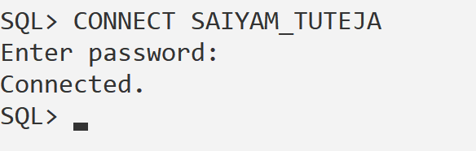

1. See list of tables using “Tab”

Solution :

**SELECT * FROM tab;**

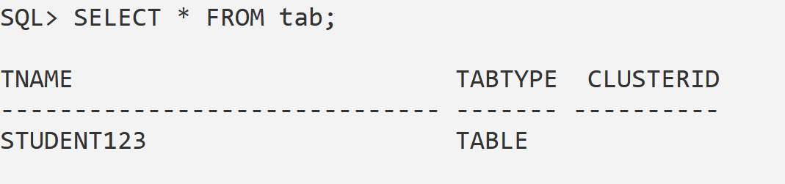

1. Write a query to create an “Employee” table with following constraints: EmpCode EmpName EmpCity DOB (date of birth) DOJ (date of joining) Salary

Solution :

**CREATE TABLE employee (**

**empcode NUMBER PRIMARY KEY,**

**empname VARCHAR2(50),**

**empcity VARCHAR2(50),**

**dob DATE,**

**doj DATE,**

**salary NUMBER**

**);**

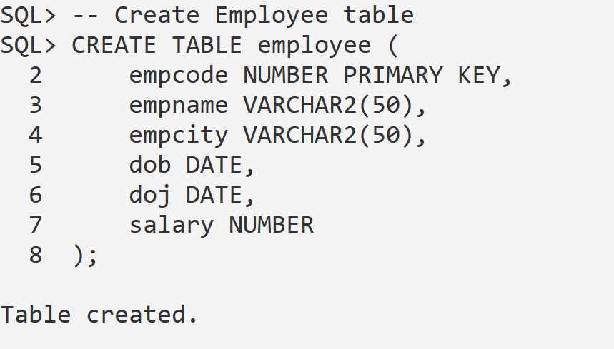

1. Display the structure of the table

Solution:

DESC employee;

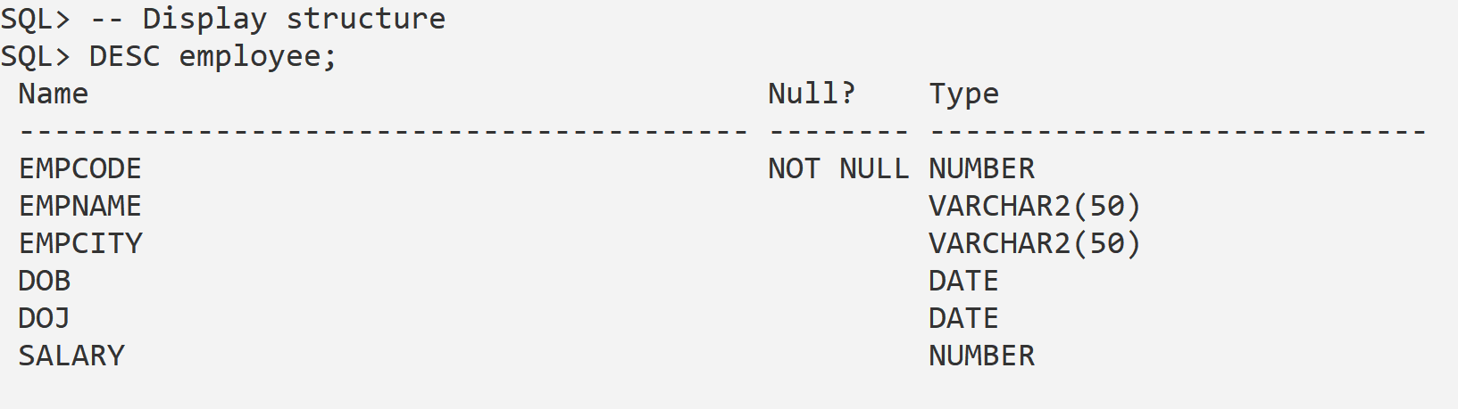

1. Insert the following data:

| **EmpCode** | **EmpName** | **EmpCity** | **DOB** | **DOJ** | **Salary** |
| --- | --- | --- | --- | --- | --- |
| 1 | Yogesh | Delhi | 01/11/1975 | 01/01/2005 | 12000 |
| 2 | Dinesh | Mumbai | 22/05/1978 | **Current** | 6000 |
| 3 | Sheena | Pune | 16/06/1989 | 01/06/1999 | 50000 |
| 5 | Sundar | Bangalore | 15/09/1990 | 01/01/2002 | 65000 |

Solution :

-- Insert values

* INSERT INTO employee VALUES (1, 'Yogesh', 'Delhi', TO_DATE('01/11/1975','DD/MM/YYYY'), TO_DATE('01/01/2005','DD/MM/YYYY'), 12000);
* INSERT INTO employee VALUES (2, 'Dinesh', 'Mumbai', TO_DATE('22/05/1978','DD/MM/YYYY'), SYSDATE, 6000);
* INSERT INTO employee VALUES (3, 'Sheena', 'Pune', TO_DATE('16/06/1989','DD/MM/YYYY'), TO_DATE('01/06/1999','DD/MM/YYYY'), 50000);
* INSERT INTO employee VALUES (5, 'Sundar', 'Bangalore', TO_DATE('15/09/1990','DD/MM/YYYY'), TO_DATE('01/01/2002','DD/MM/YYYY'), 65000);

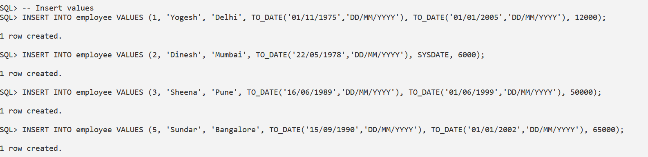

1. Execute the following queries:
2. Select empname,DOB from employee

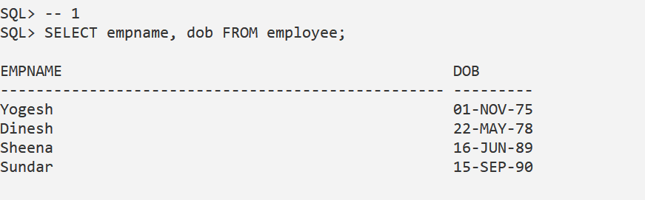

1. Select empname, DOB, sysdate from employee.

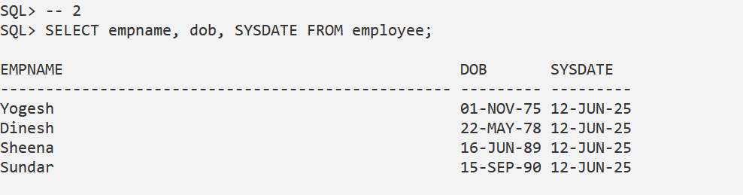

1. Select empname, DOB, DOB + 15 from employee

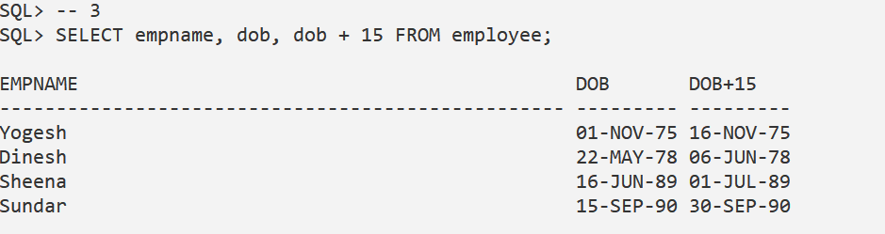

1. Select empname, DOB,DOB-3 from employee

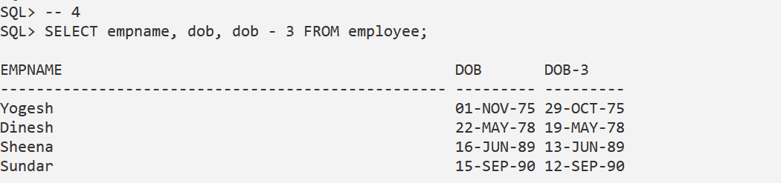

1. Select empname, DOB, TO_CHAR(dob,’DD MM YYYY’) from employee

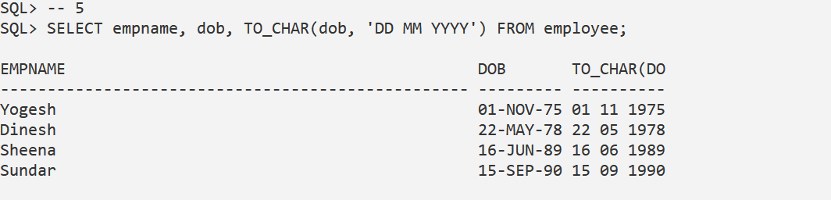

1. Select empname, DOB, TO_CHAR(dob,’Day Month Year’) from employee

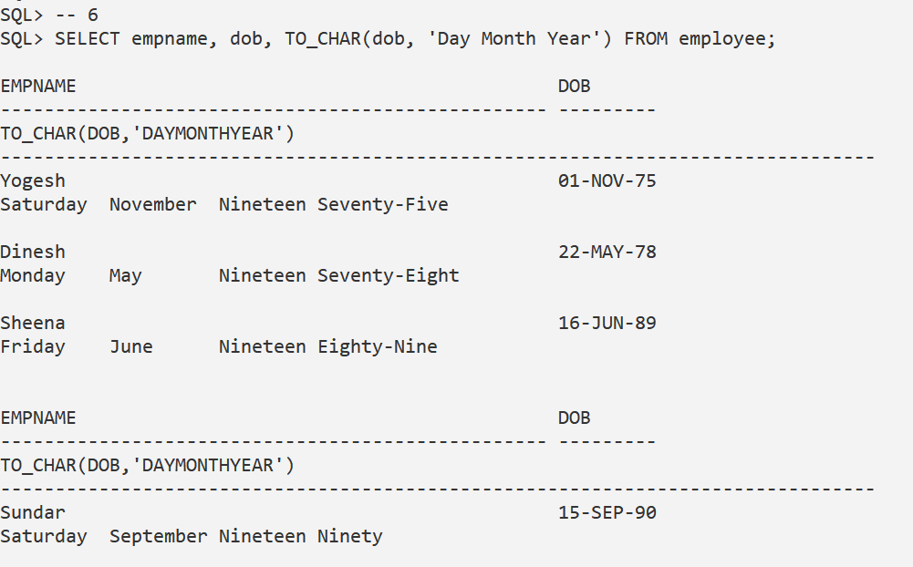

1. Select empname, DOB, TO_CHAR(dob,’Day MON Year DD MM YY’) fromemployee

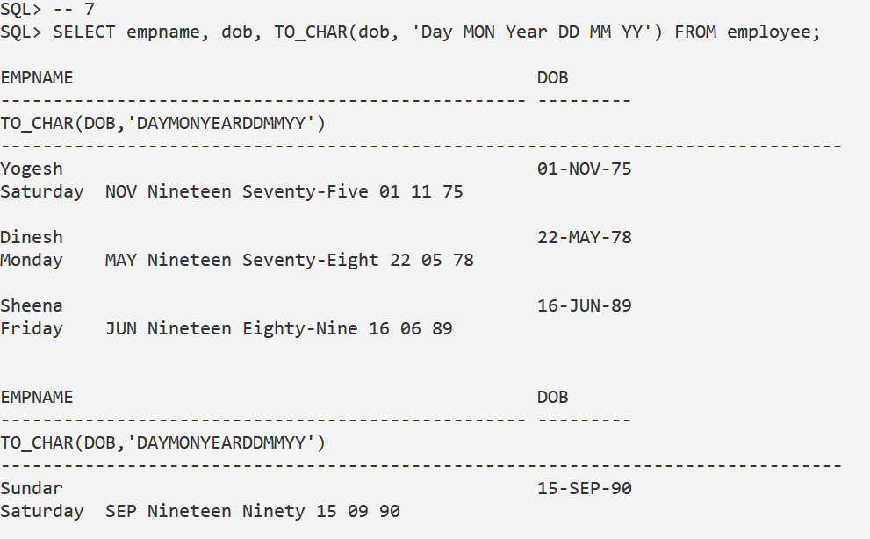

1. Select empname, DOB, TO_CHAR(dob,’DD DD MM MM YY YYYY YYYY’)from employee   
     
   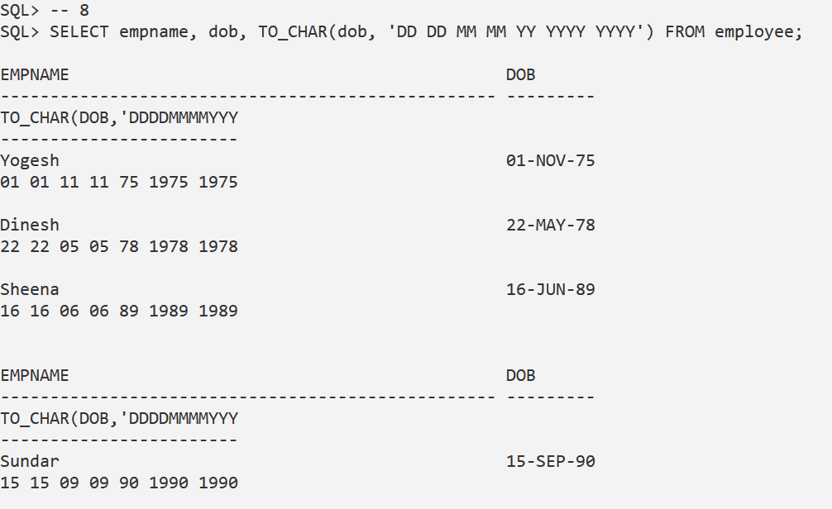
2. Select empname, DOB, TO_CHAR(dob,’DDsp MMsp YYYYsp’) from employee  
     
   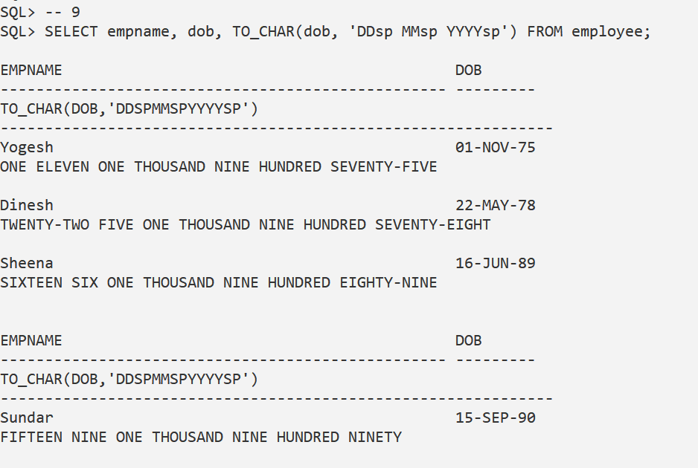
3. Select empname, DOB, TO_CHAR(dob,’DDspth MMspth YYYYspth’) from employee

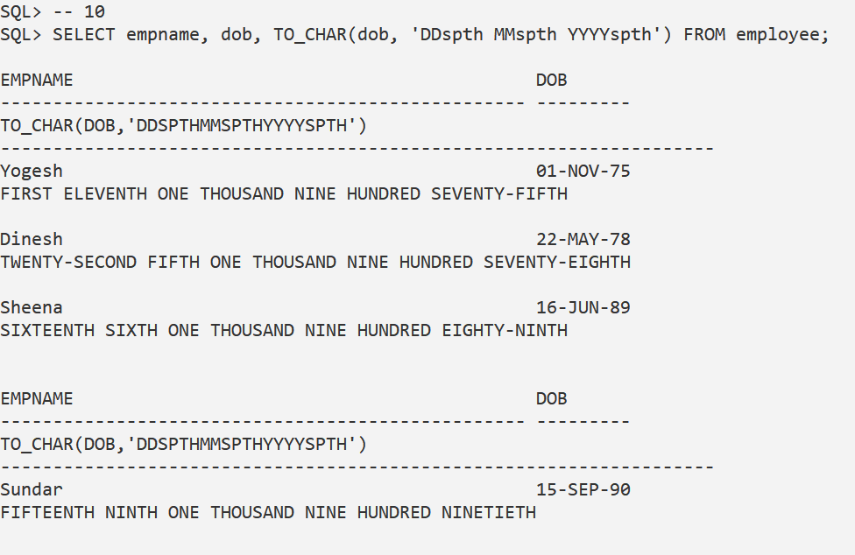

1. Select empname, DOB, TO_CHAR(dob,’DDsp MMspth YYYYsp’) from employee

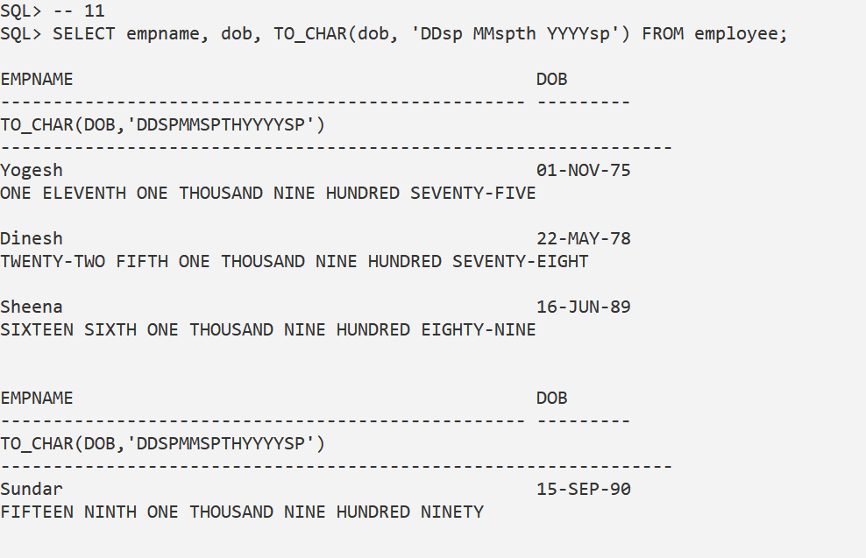

1. Select empname, DOB, TO_CHAR(dob,’DD MM YYYY HH MI SS’) from employee   
     
   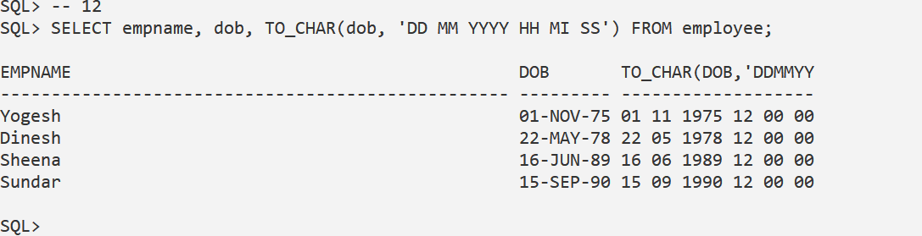
2. Select empname, DOB, TO_CHAR(dob,’HH MI SS’) from employee   
     
   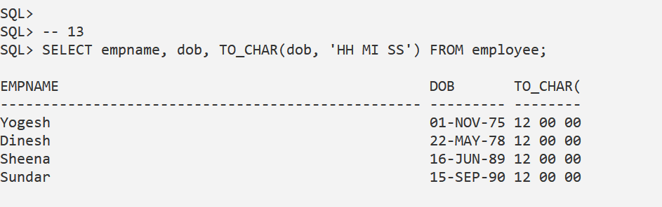
3. Insert into employee values(4,’Amit’,’Meerut’,’1-Jan-67’,’21-Sep-04’,15000)  
      
   
4. Select empname, DOB, TO_CHAR(DOB,’DD MM YYYY’), TO_CHAR(DOJ,’DDMM YYYY’) from employee where empcode=4   
     
   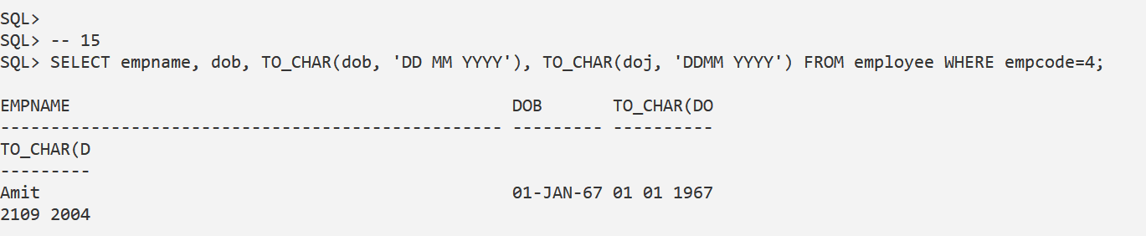
5. Insert a record with DOB=1674 and DOJ=1734   
     
   
6. Display this record with full year in DOB and DOJ   
     
   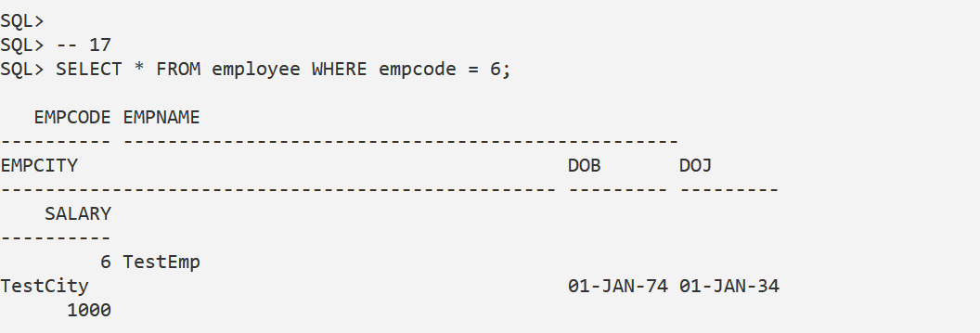
7. Write queries for the following:
8. Show all records   
     
   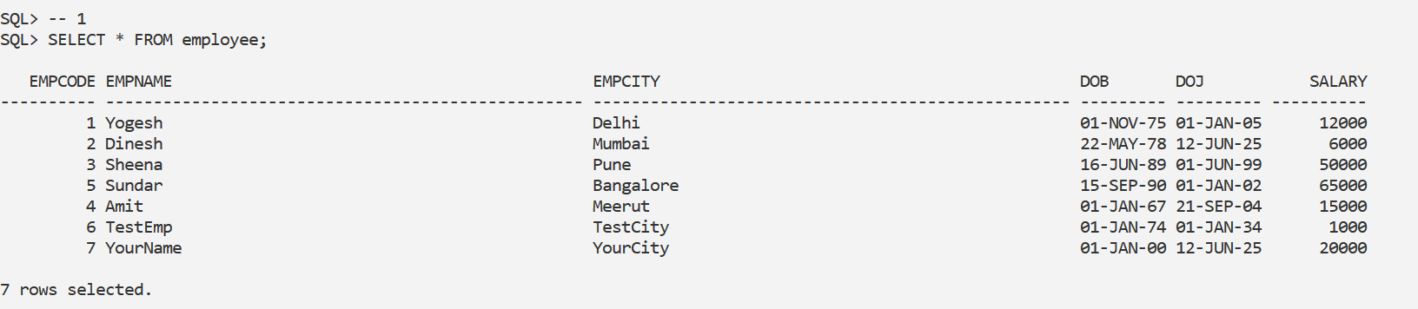
9. Show names and salary of all employees   
     
   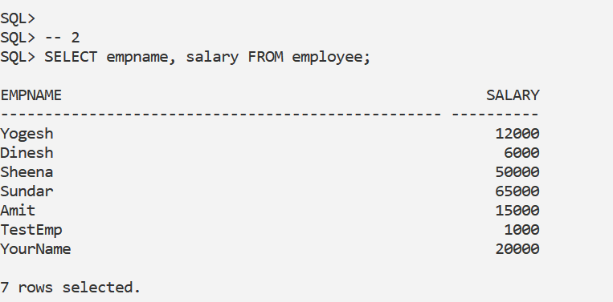
10. Display highest salary  
      
    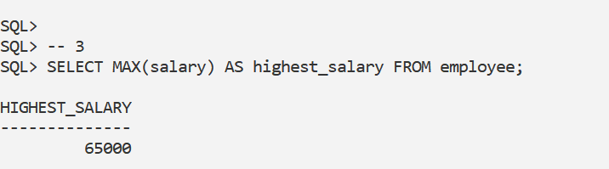
11. Display lowest salary   
      
    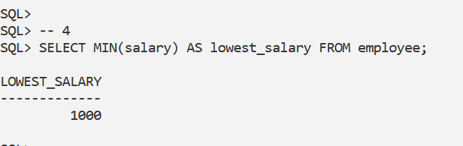
12. Show the total number of records   
      
    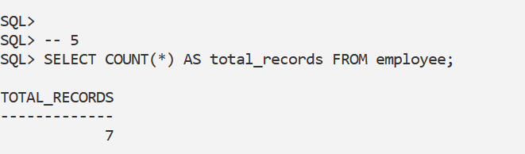
13. Display the empname, actual salary and salary with 15% increment   
      
    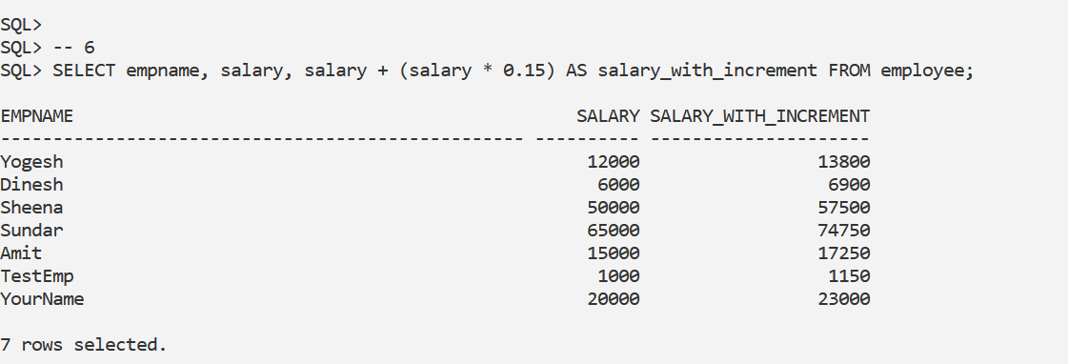
14. Display all records in format: “The Salary of Yogesh is 12000 and he belongs toDelhi”  
      
     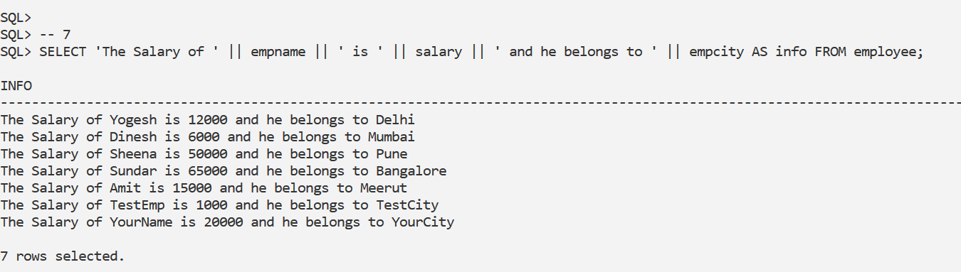
15. Display the total number of characters in all employee names   
      
    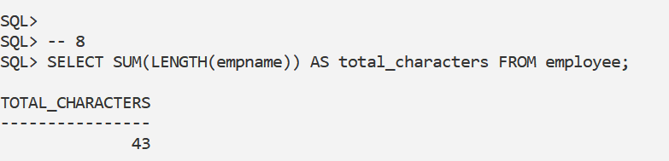
16. Display all employee names in Capital Letters   
      
    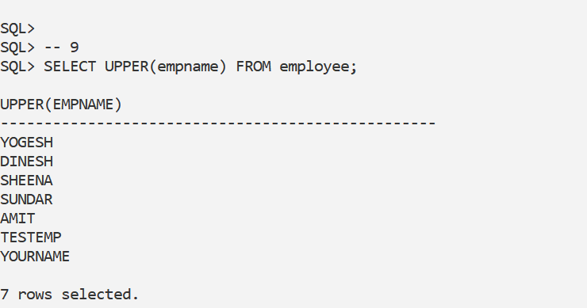
17. Display all cities in Small Letters   
      
    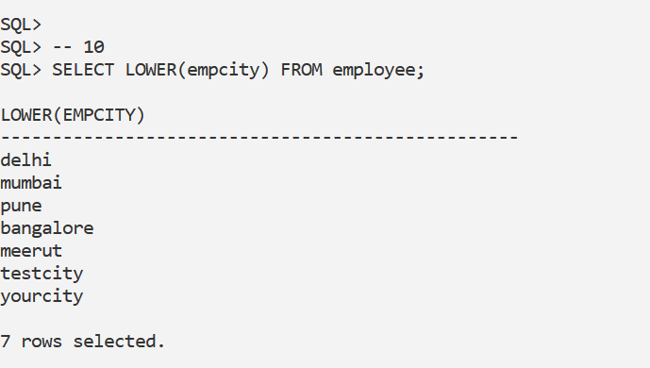
18. Display names in Initial capital letters.  
      
    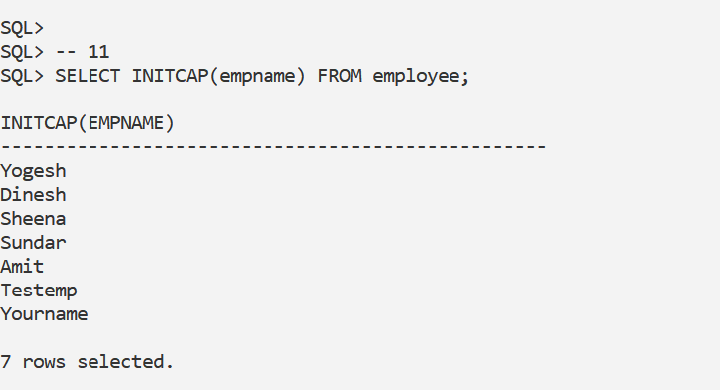
19. Display only current date   
      
    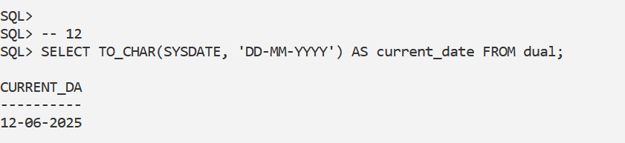
20. Display only current time   
      
    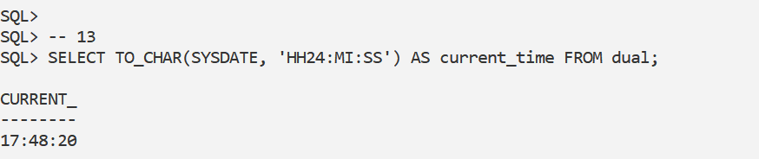
21. Display the current date and time   
      
    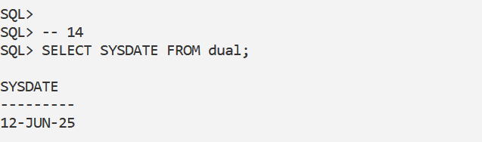
22. Display only current year   
      
    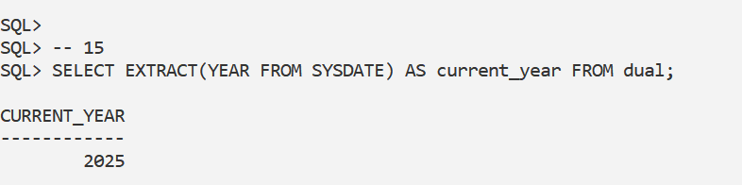
23. Display only current month   
      
    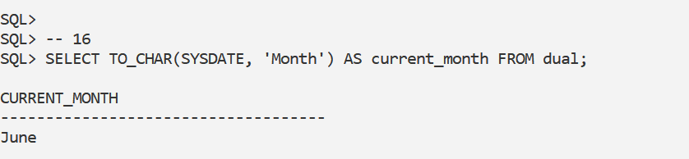
24. Display all records in following format: “The date of birth of Yogesh is 1 NovemberNineteen Seventy Five”   
      
    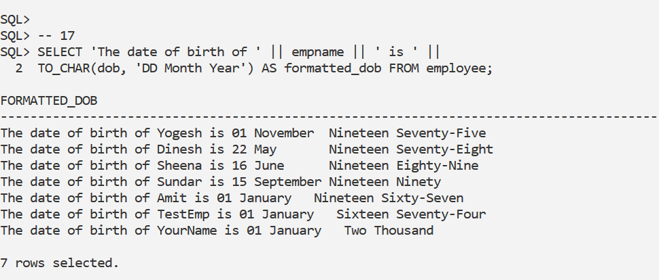
25. Display the total number of months an employee is working   
      
    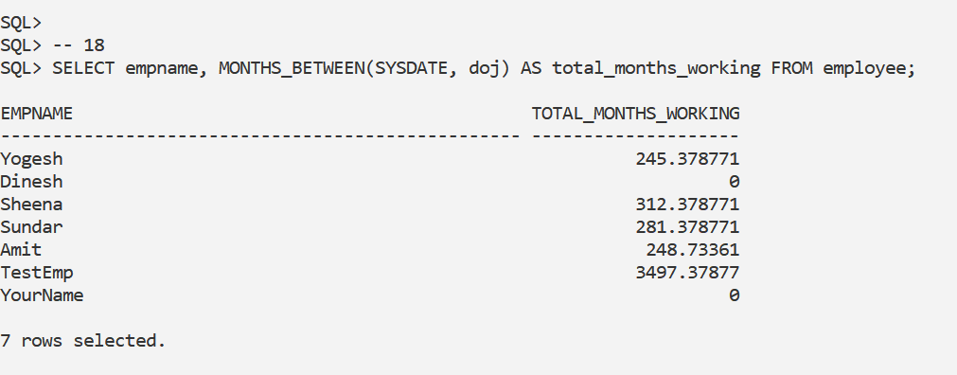
26. Display the name and age of each employee   
      
    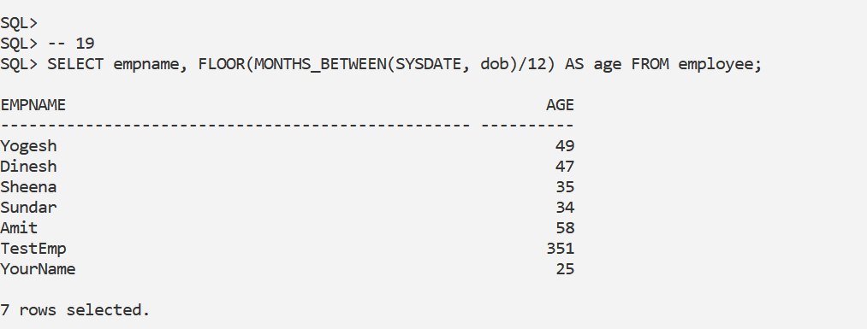
27. Display total experience of all employees in years   
      
    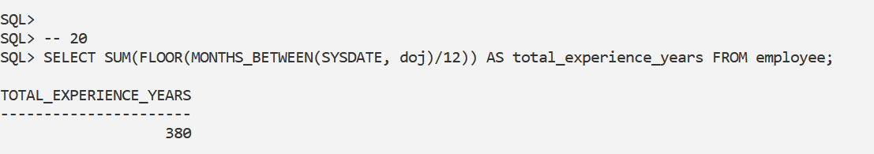
28. Display the full 4 digit birth year of all employees   
      
    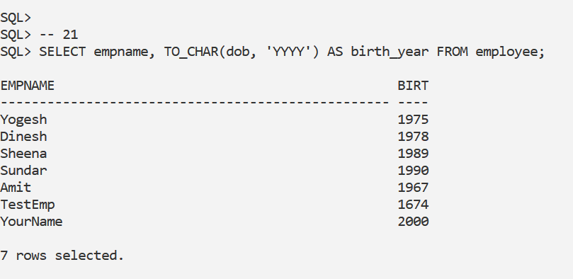
29. Enter a record with your detail in the table with your actual DOB  
      
    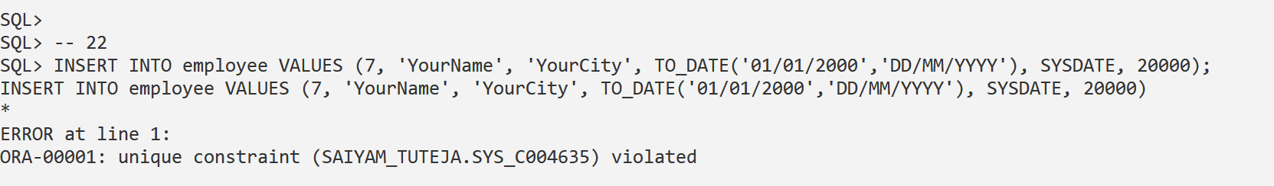
30. Display on which day you were born   
      
    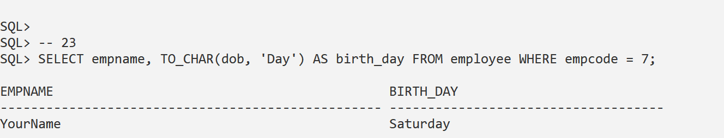
31. Display all list of employees who were born after your dob   
      
    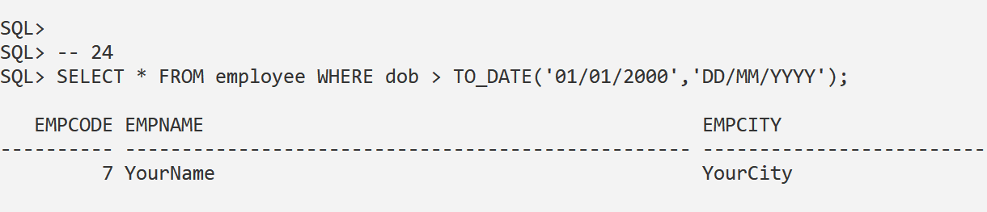
32. Delete your record   
      
    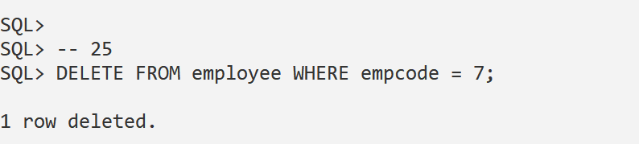
33. Again enter your record but this time enter your birth time also   
       
    
34. Display names, DOB, Time of Birth, age of all records  
      
    